**Assignment 1 Name: Kadin DeMesme**

1. Install the latest version of the following browsers (or the browser of your choice). Please check the checkbox and write down the version of your browser once you are done. You need to have at least three different browsers to test your program.

Internet Explorer or Microsoft Edge or Safari _______Microsoft Edge___________________



FireFox or any other browser _____FireFox________________________ Chrome _________Chrome___________________



1. Please create the following folders in your main website directory.

doc img css



js

1. Please created a HTML5 document that

Named “index.html”

Title of the document: CSCI225 Homepage of __Kadin D._____ (Put your name)

Contains an unordered list of at least five items -- DIV box with class name **navbar** o Hyperlink to USCA main websites o Internal link to Assignment Section o Internal link to Contact Information Section o Other links of your choice



Contains an Introduction Section –DIV box with class name i**ntroduction** o Use h1 for Section Title “Introduction”

* + Use p for a paragraph that contains a brief introduction (At least four or five sentences)

about yourself. o Use IMG to insert a picture of your choice in this section

Contains an Assignment Section-- DIV box with class name **assignment** o Use h1 for Section Title “Assignment”

* + Contains an ordered list of homework assignment

The first item is a link to Assignment1.pdf

Contains a Portfolio Section—DIV box with class name **portfolio** o Use h1 for Section Title “Portfolio” o Contains list of your previous projects



* + Short description of your projects and technical skills involved

Contains a Contact Information Section—use **address** element o Use p for Section Title “Contact Information” o Contains a mail to link to your email address

* + Or other contact information that you want to share with the public o Please do not put your cell phone and/or home address on public website

Contains a Schedule Section--- DIV box with class name **schedule** o use h1 for Section Title “Schedule”

* + Create a simple table to show your current course schedule. (Please **do not share** your real schedule if you have privacy concerns)
  + (Extra Credit) You may create a complex table as the one on the back.

Contains a Copyright Section --- use **footer** element.

Use at least three decoration/editorial tags which were not covered in class. Tag names are

____<i></i> , <strong></strong>, <sub></sub>, <em></em>.

You might put other information in this page as long as the contents are appropriate.



1. Before you submit your file, be sure to check this checklist.
2. Validator your file through <http://validator.w3.org/check>



1. Upload index.html, Assignment1.pdf, the image of your choice to your github CSCI225 repository. Please make sure you put them in the right folder.



1. Test your submission ---Go to your course website http://xxxx.github.io/CSCI225 (XXXX is your github username) using all three types of web browser. Make sure all links are working!



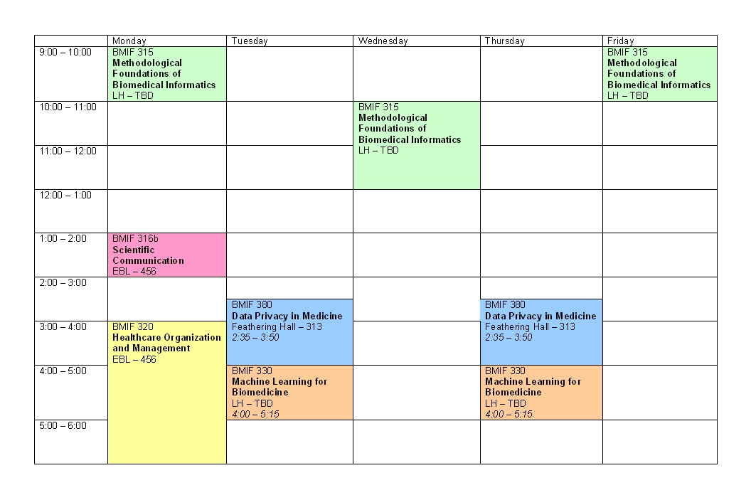

A complex course schedule sample. Use rowspan appropriately!